Sandy Kleinhenz
Mortgage Financing Fun Facts

October 1, 2015= new RESPA/ Closing Docs guidelines are implemented!!!

LTV= Loan to Value loan amount/ appraised value ex: $100,000 / 160,000= 63% LTV

PI= principal & interest. *Make monthly payments to principal EACH month, preferably the equivalent of a monthly payment/12. This accelerates your amortization more than making 1 extra payment per year.

PITI= principal, interest, taxes and insurance

MI (PMI)= Mortgage Insurance or Private Mortgage Insurance
Conforming= LTV >80% needs monthly MI (there is lender paid MI but interest rate is higher). .55% factor
FHA= there is 1 time UFMIP (up front MI Premium= 1.75% of loan amount) plus monthly MI @ 1.35%

DTI- Debt to Income Ratio (This has a front end and back end ratio).
Front end ratio (first #)= housing expense-to-income ratio. This is your proposed mortgage payment (principal, interest, taxes and insurance) PITI divided by your gross monthly income. (Ex; $1200/$5000= 24% DTI)
Back End Ratio (2nd #)= total monthly obligations-to-income ratio. This is your gross monthly payment including Mortgage PITI divided by your gross monthly income. $2500/ $5000= 50% DTI
Conforming= 28/36 ratio is standard with >620 score but can be higher with DU Approval.
FHA= DU approval (I’ve seen > 55% approved with compensating factors).

Free Credit Report Annually= www.annualcreditreport.com (don’t be fooled by other websites with memberships)

Credit Bureaus:
Equifax (EFX)- 800-846-5279 www.equifax.com or CSC Credit Services 800-392-7816 www.csccredit.com
Experian (XPN)- 888-397-3742/2 www.experian.com
Trans Union (TU)- 800-916-8800/3 or 800-888-4213 www.transunion.com

“PLAY THE CREDIT CARD GAME”
You NEED to have and use at least 3 credit cards monthly to have a good credit score but you must be responsible and pay them off each month. However, too many open credit cards can be a red flag.

Understanding the Credit Ratio= current balance/high balance= credit ratio ex:($1000/ $3000= 33.33%)
Ideal ratio is 30% but keep less than 40% of the high limit. If you need a “Quick Fix”- call creditor and ask them to increase your limit but you’re not allowed to use it!

It’s best to pay down larger debts first, since larger missed payments count for more points.

If you’re financially savvy and dependable, take advantage of new credit card offers with low interest rates. Transfer some of the balance from credit card with high ratio to new card. Be sure to keep track of when new credit card offer expires and close it before opening another one until you pay balance off.

Rapid Rescoring= This updates your credit report that’s incorrect or if there’s a change in credit status which can potentially increase your score. We get updated credit report within 3 days that we can send to lender.

Credit Inquiries= Inquiries may or may not affect your FICO score.
A FICO score takes into account only voluntary inquiries that result from your application for credit. The information about inquiries that can be factored into your FICO score includes:
Number of recently opened accounts, and proportion of accounts that are recently opened, by type of account, Number of recent credit inquiries, Time since recent account opening(s), by type of account and Time since credit inquiry(ies).
A FICO score does not take into account any involuntary inquiries made by businesses with whom you did not apply for credit, inquiries from employers, or your own requests to see your credit report.

For many people, one additional credit inquiry (voluntary and initiated by an application for credit) may not affect their FICO score at all. For others, one additional inquiry would take less than 5 points off their FICO score. Inquiries can have a greater impact, however, if you have few accounts or a short credit history. Large numbers of inquiries also mean greater risk.
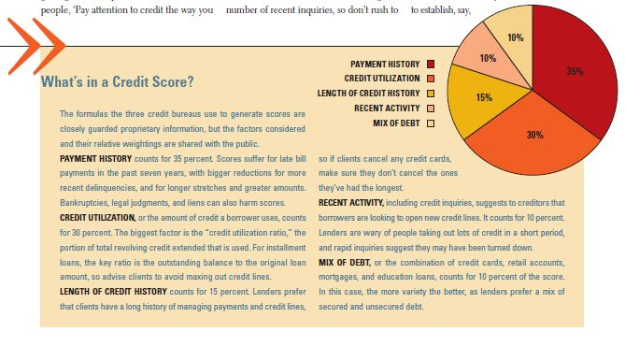
Dispute Credit= dispute your credit online with the reporting bureau expecting a 30 day reply.

*Collections= You can try to call the creditor directly to dispute it if paid. There are very specific requirements their letter must have in order for the bureaus to “remove from the credit report” (call me)!

*MEDICAL Collection(unknown name)- 800-846-5279(if <$100, they may remove from credit)
* If you pay an old 3yr+ collection it becomes a current paid collection and your score will temporarily go down!!

PVA Dispute= Dispute your tax assessed value
Appointments available once a year April-May. Call 574-6380 /1 for this year’s dates.
http://jeffersonpva.ky.gov/forms-tools/appeal-process/

FRAUD ALERTS added to Credit Report: 800-525-6285/1 (says Equifax but does all bureaus)

OPT-OUT: You may request that consumer credit reporting companies exclude your name from lists for pre-approved, unsolicited credit and insurance offers. To find out more, please call 1–888–5OPTOUT (1–888–567–8688).

REFERRALS I NEED

If you hear someone say they are already pre-qualified say:

“I know a great loan officer that may be able to beat your rate and answers her phone when you call! You have nothing to lose and deserve the best. May I give her your name and number and have her call you?”

A great referral for me is anybody you hear saying:

“I always go to a bank for my mortgage, My bank is taking forever, I need to refi, I need a home, I’d love to buy a home but I’m not sure I’ll qualify, I’m getting married, I’m getting a divorce, My apartment, My rent, My loan officer won’t call me back, I’ve heard rates have dropped, I know someone who is in foreclosure, I ‘ve had a BK or know someone who had one, I need new windows or other home improvements, My credit is bad, I have so much credit card debt, etc.”

“SELECT SANDY” for a Smooth and Successful Closing!!
502.931.0298 C 502.410.0477 FX
Sandy Kleinhenz (NMLS#20028) Select Mortgage (NMLS #855358)
sek@twc.com www.sandy-k.com www.twitter.com/selectsandy www.linkedin.com/in/sandykleinhenz

